Step3:

Select “Add SVN Repository” and enter the URL of the repository as **file:///C:\SVN\Mandatory**.  
The repository gets added to the SVN Repositories

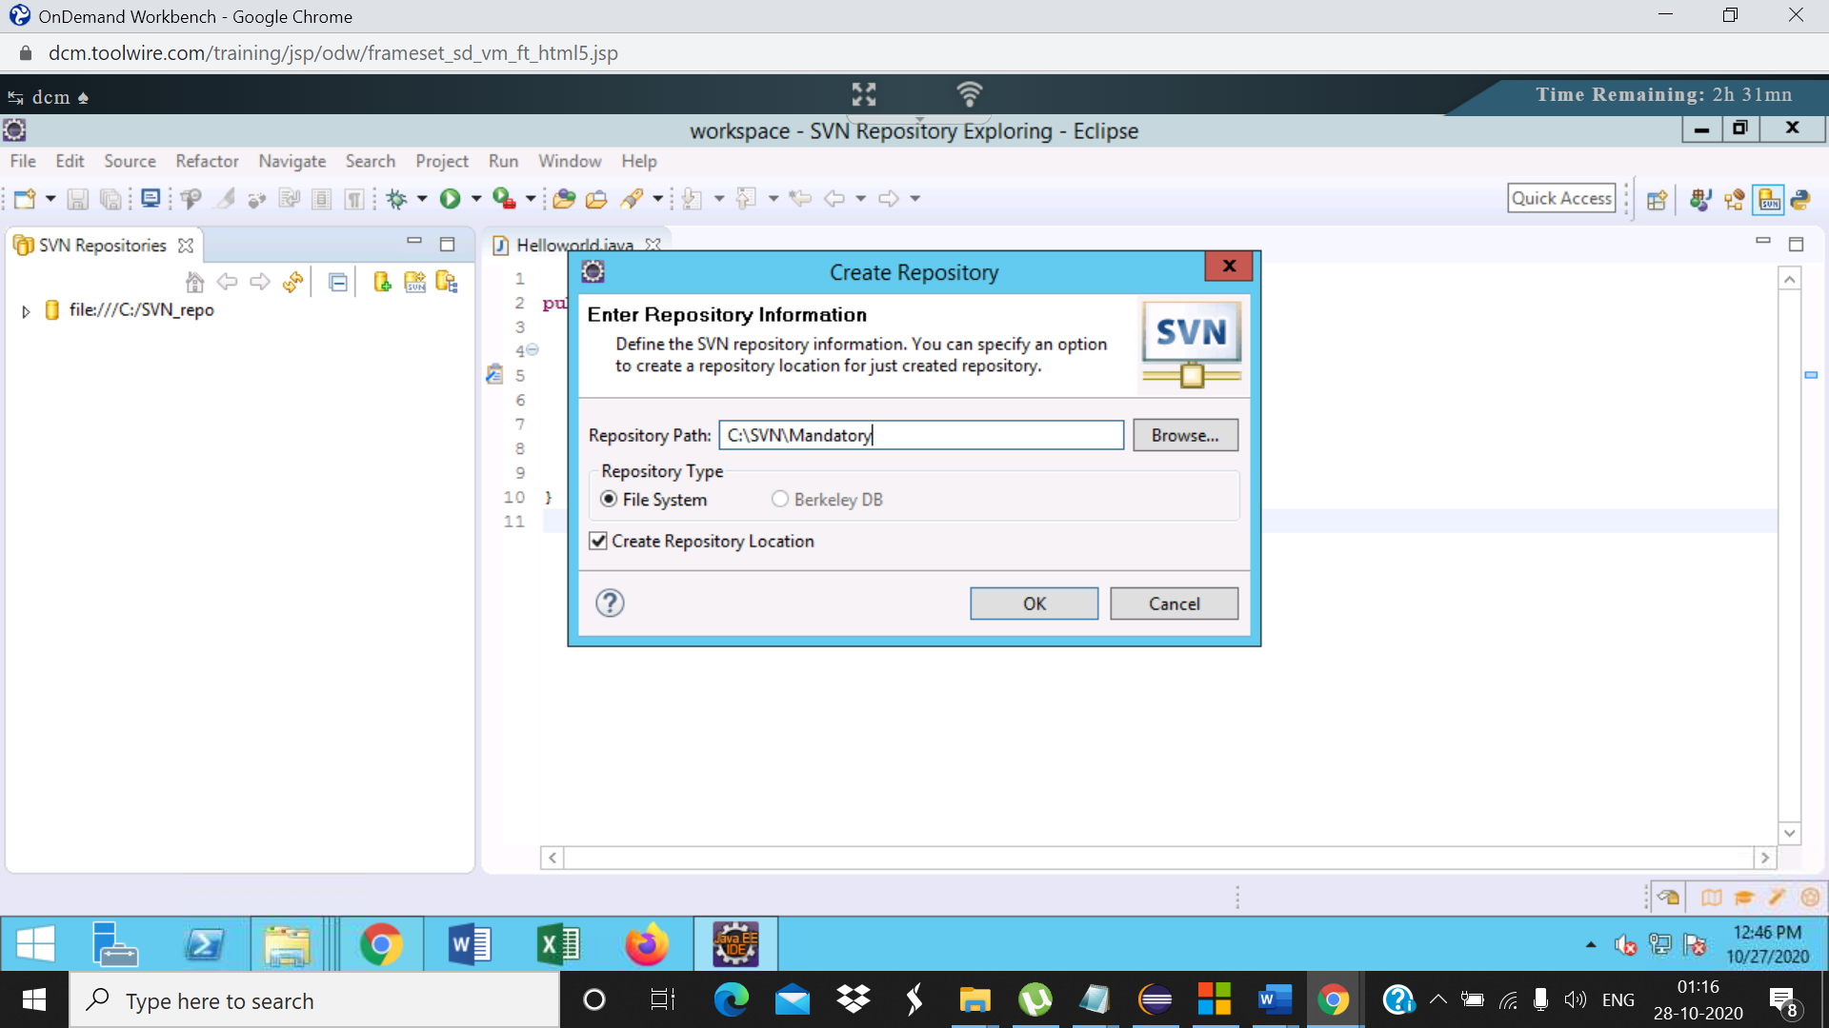

Step4: Right click on the project named as **project9** inside trunk and select Checkout

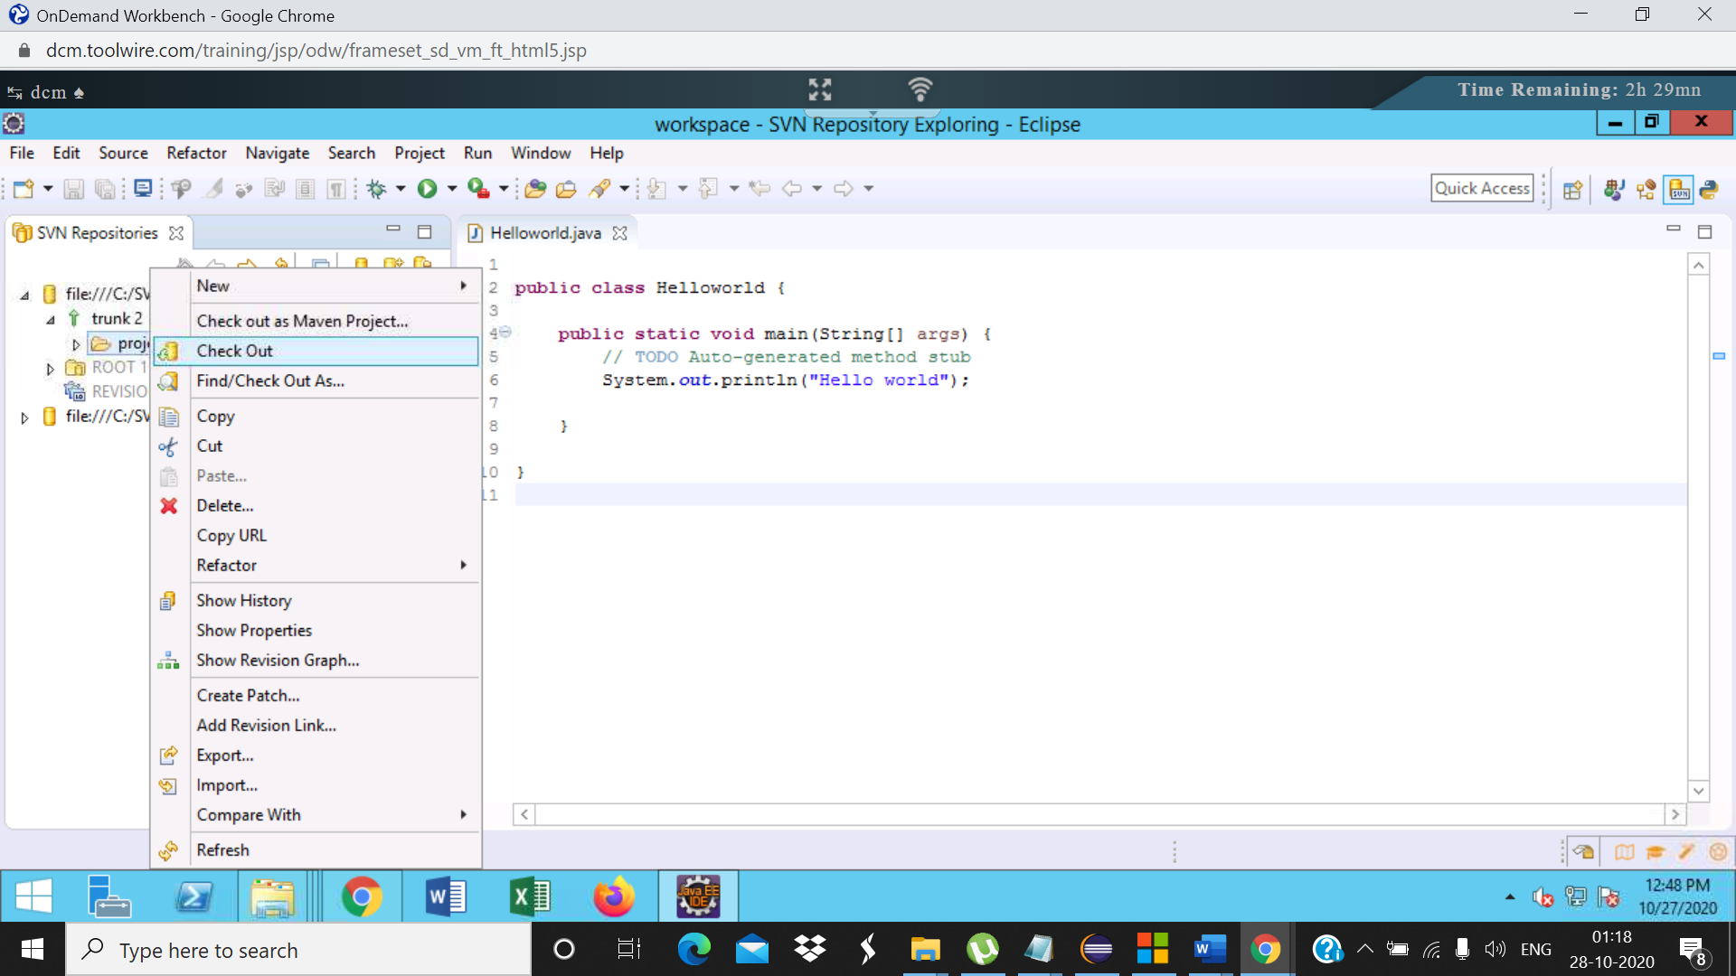

Step5:

Select “Check out as a project in the workspace” and specify the project name in the Checkout from SVN dialog.  
Click on Finish  
The project will be checked out to the workspace.  
Project name: Shipment_user1

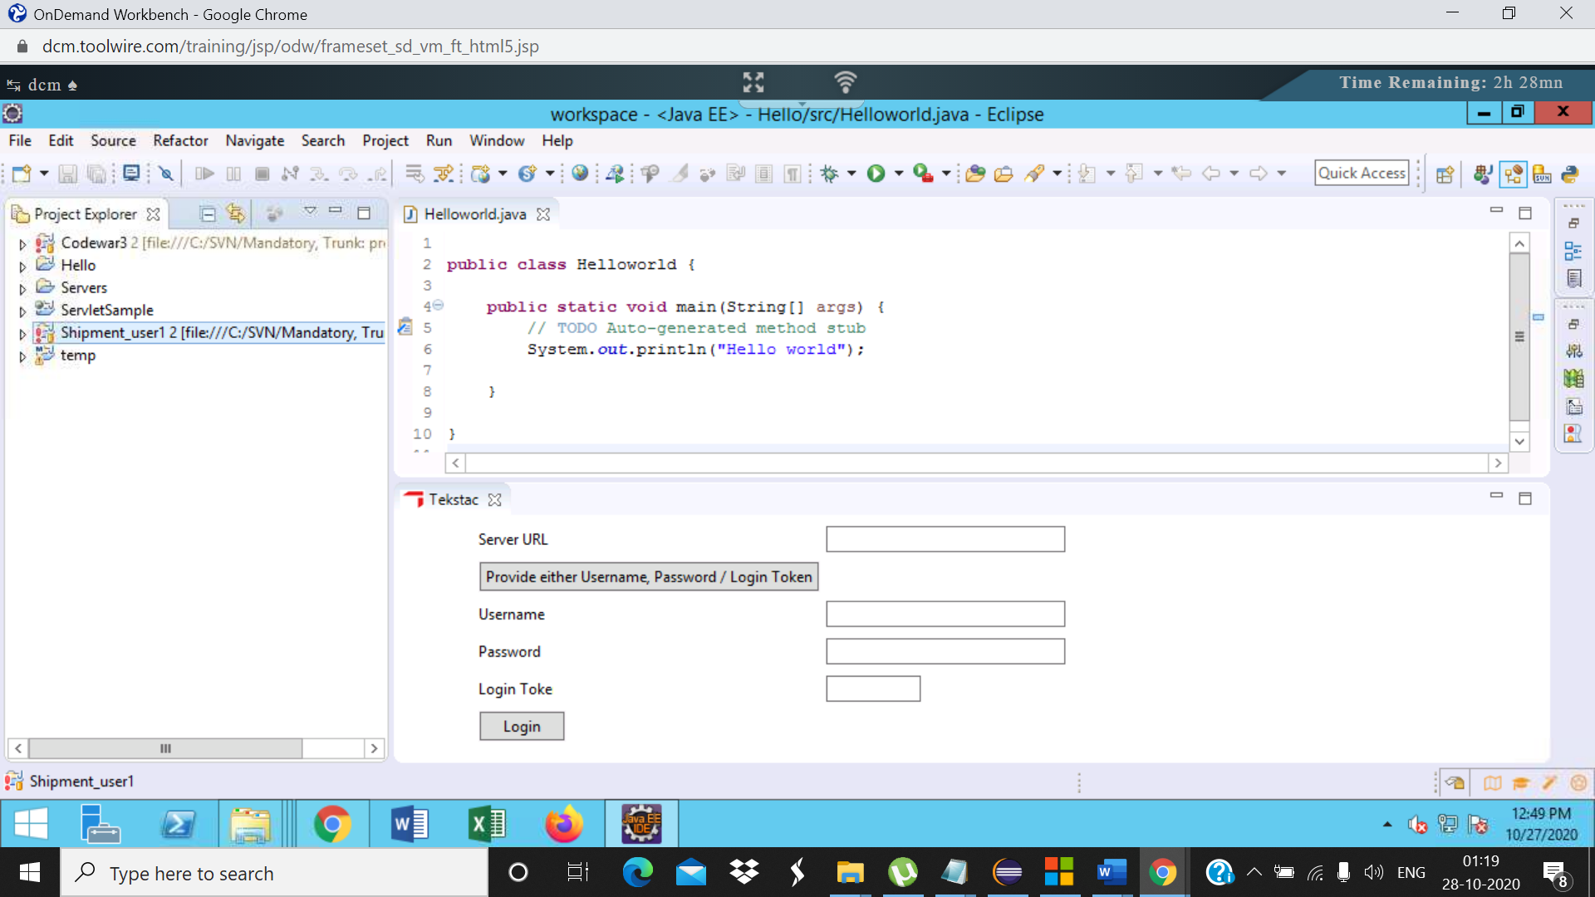

Step6:

|  |  |
| --- | --- |
| In the SVN Repository, check out the same project again with a different name. Project name: Shipment_user2 |  |

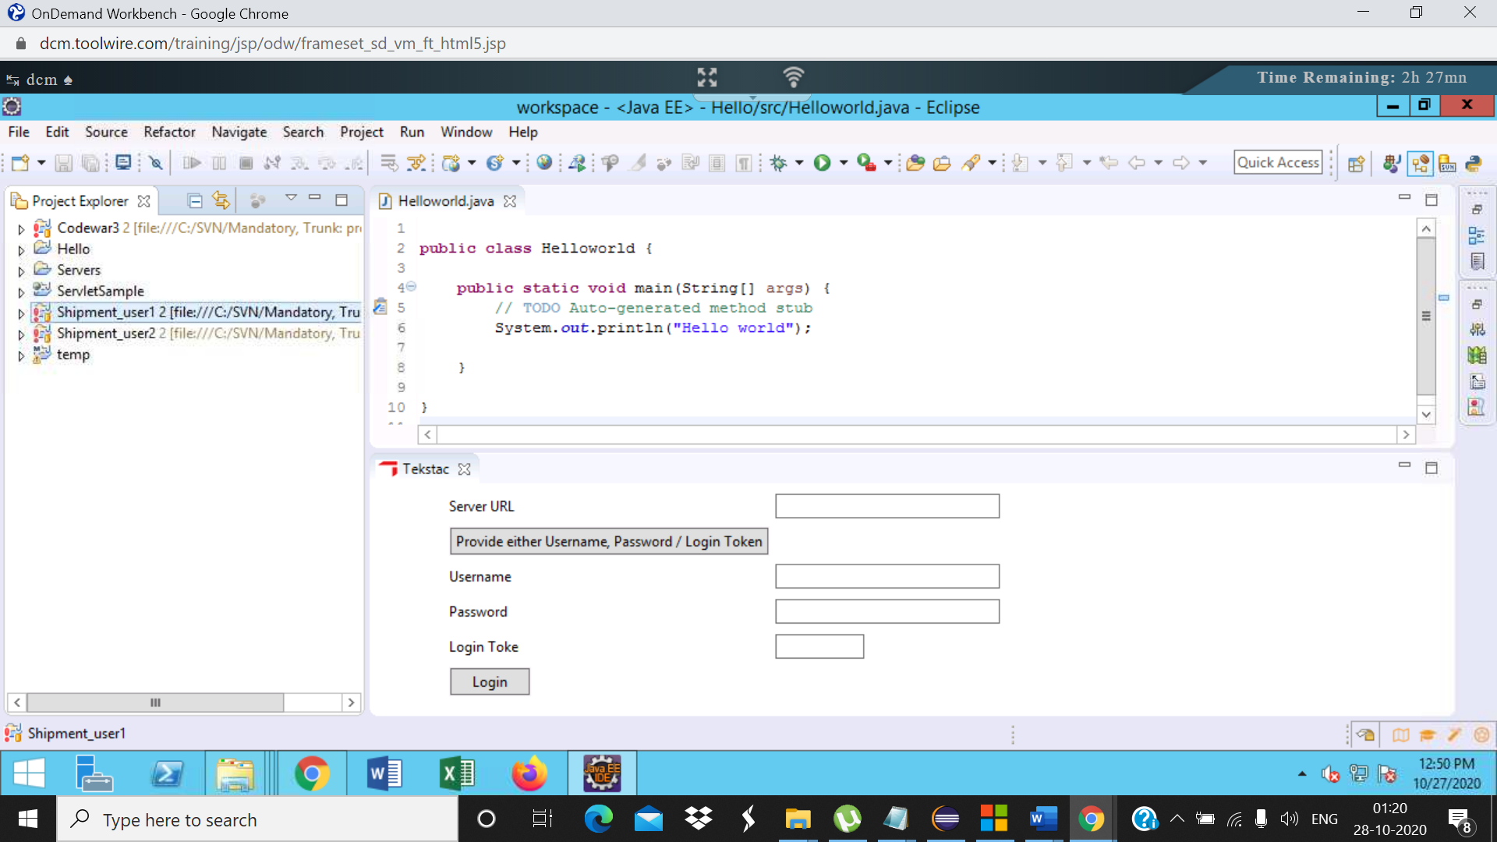

Step7: Open the Shipment_user1 project from the Project Explorer and modify the Main.java file. In line 10, update the variable name from br to bufferedReader and save the file

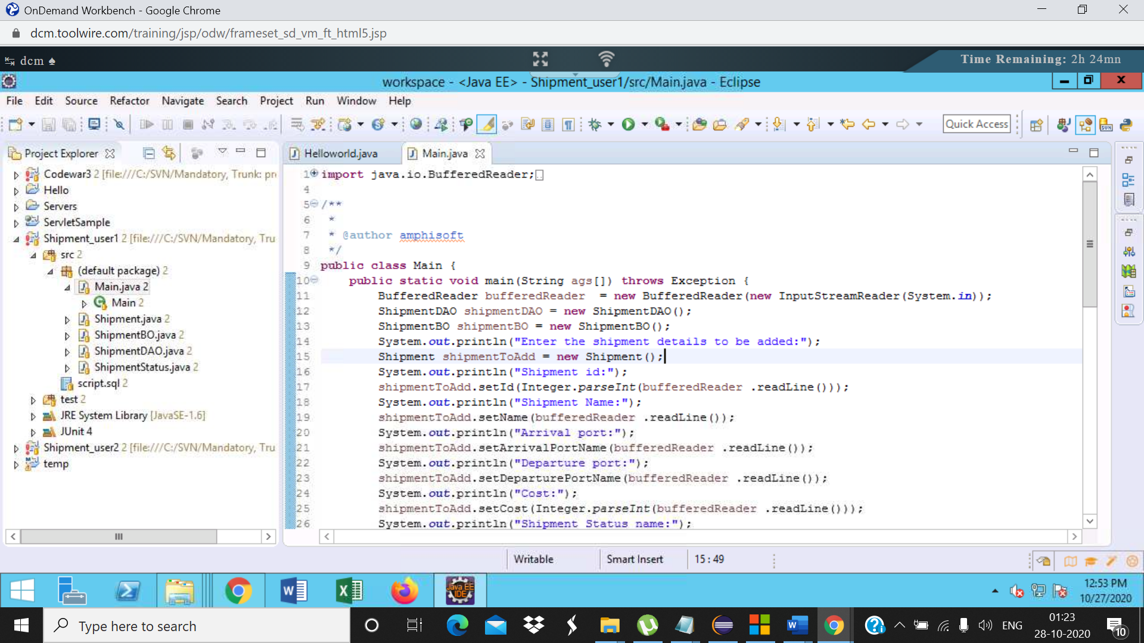

Step 8: Right click on the file, select Compare with->Latest from repository  
Verify that only the required changes are made

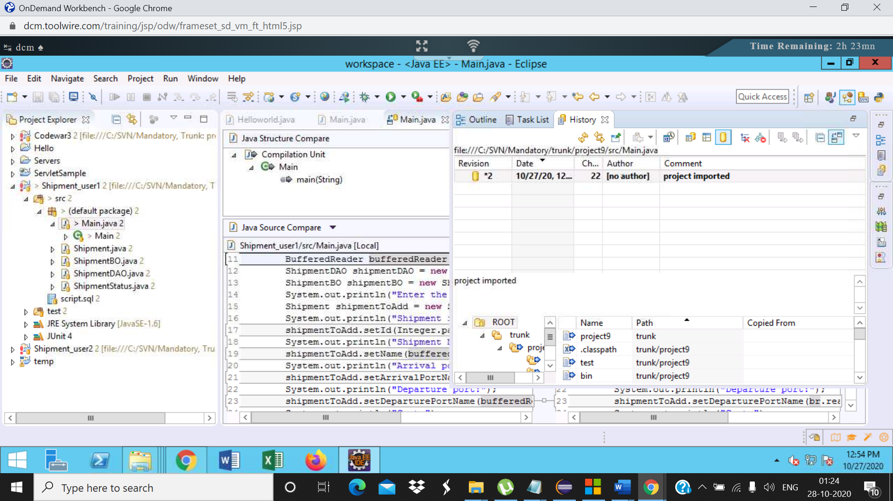

Step9:

Right click on the project, select team->commit  
Verify the files in the changes section of the commit dialog. Only the Main.java file should be present

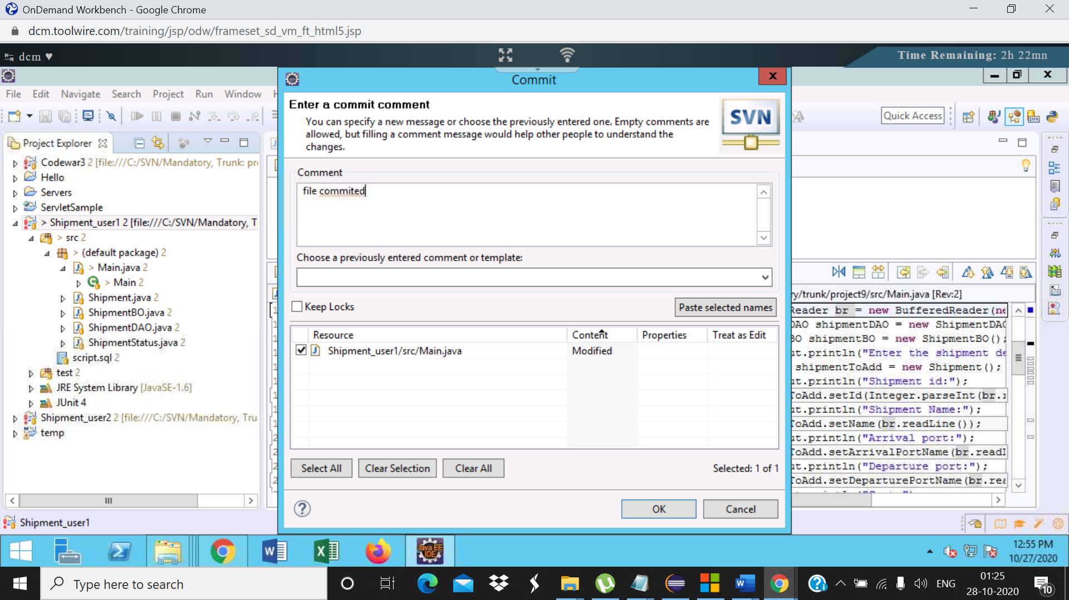

Step11: Open the  Shipment_user2 project from the Project Explorer and update the ShipmentBO file. Update the variable name in line 8(for loop) from s to shipment. Save the file

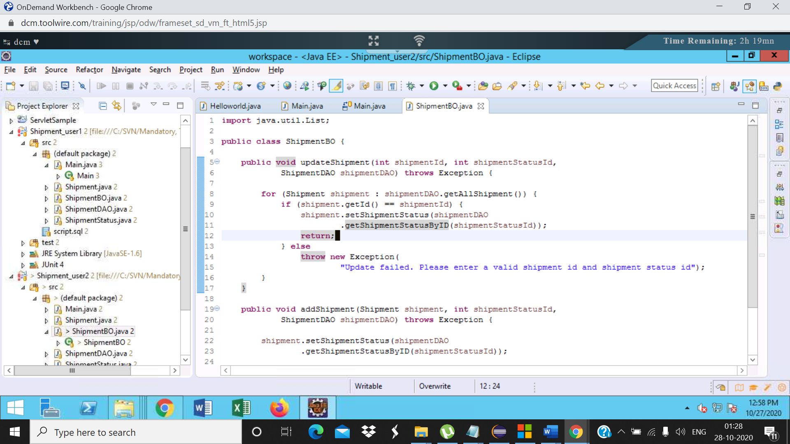

Step12: Right click on the project,  
select team->update to HEAD. No conflicts occurs, the project is updated successfully.  
Then select team->commit  
Verify the files in the changes section of the commit dialog. Only the ShipmentBO.java file should be present

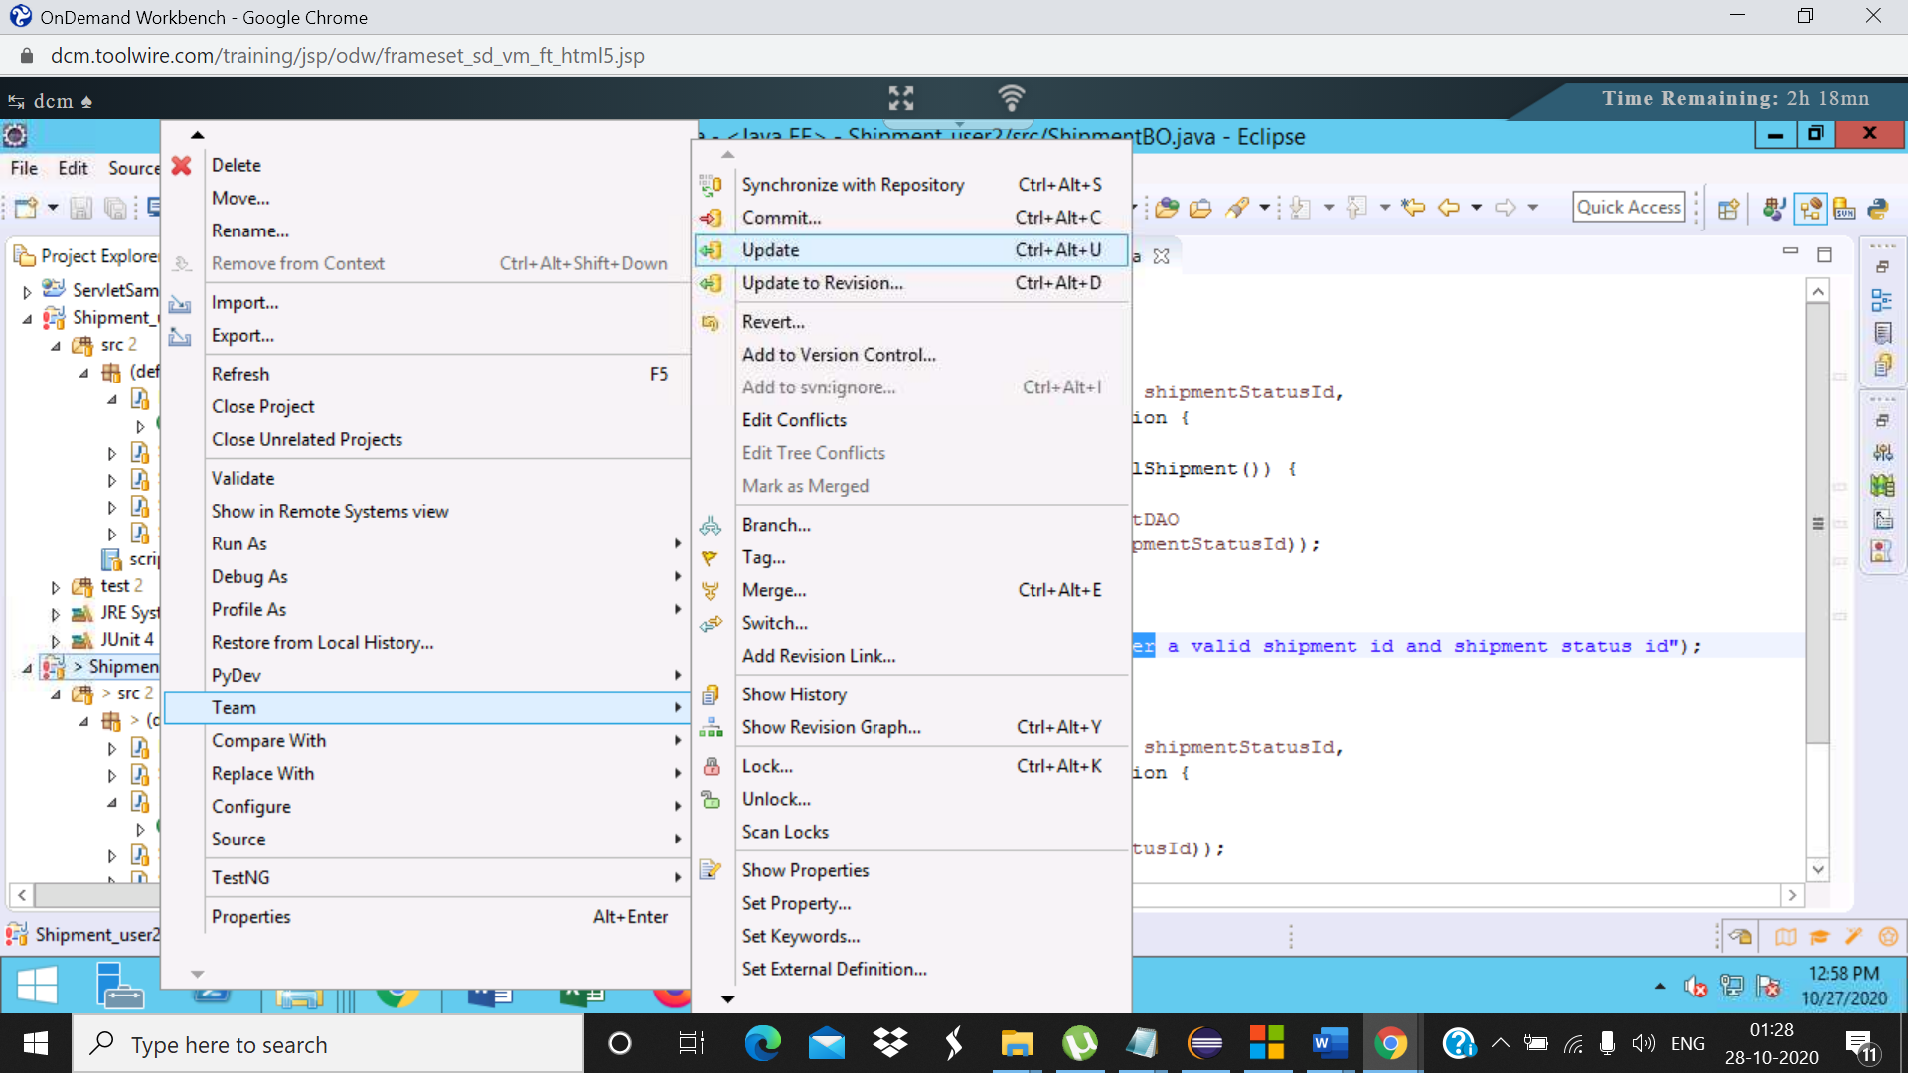

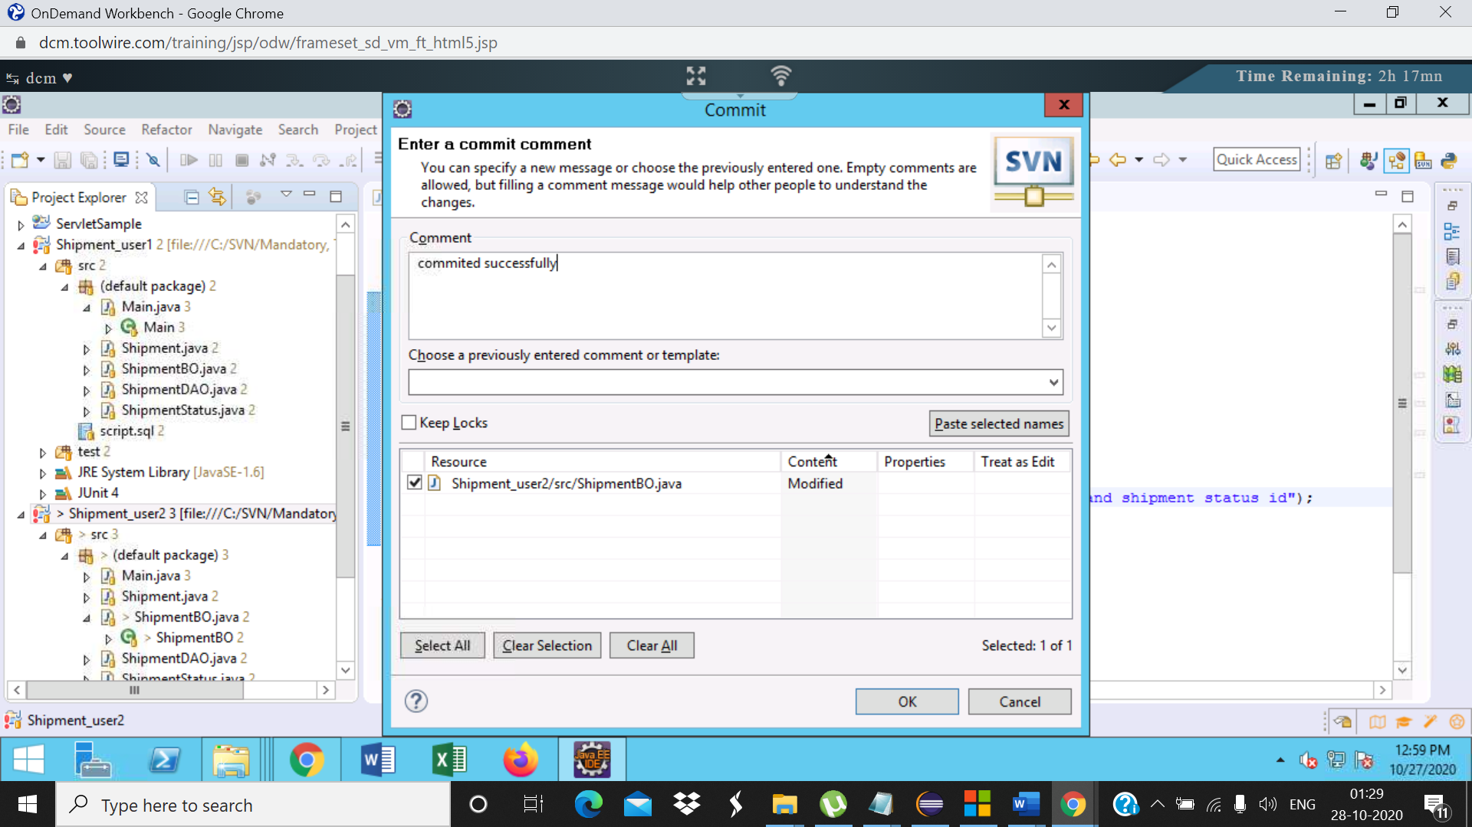

Step14

Right click on the repository and select show history

